DRAFT SAMPLE EXAMINATION

MARKING KEY

2008/19628

SECTION ONE
Question 1 (a)

Visual analysis
- Identify and discuss key features of artwork, commenting on literal and/or symbolic meaning
- Recognise how the artwork has been constructed, identifying specific art elements and principles
- Discuss materials, techniques and processes used in artwork, discussing mood created
- Interpret and make judgements about the artwork using the frames
10–9 | 8–7 | 6–5 | 4–3 | 2–1
Detailed analysis of artwork that explains both the aesthetic qualities and conceptual meanings communicated with selective use of art language. | Objective analysis of artwork and identification of key meanings communicated, using appropriate art language. | Basic analysis of artwork focused mainly on the formal aspects and/or key features, using a limited range of art language. | Analysis of artwork restricted to being largely descriptive and/or emotive with limited use of art language. | Inadequate analysis of artwork with minimal use of art language.
Meaning and purpose
- Offer reasons for why the artwork was produced, discussing some key concepts communicated
- Interpret the meanings communicated by the art work, commenting on stereotypes presented
- Discuss the artwork, commenting on possible meanings conveyed
10–9 | 8–7 | 6–5 | 4–3 | 2–1
Informed and thorough discussion of concepts, meaning, purpose and value of artwork, synthesising varied or conflicting interpretations. | Comprehensive interpretation of meanings communicated in artwork. | Straight forward and literal interpretation of artwork and its meaning. | Limited description of artwork. | Little or no attempt to discuss the meaning and purpose of artwork.  Inadequate response.

Total marks /20

Additional notes for markers
 | Visual analysis
For copyright reasons this image cannot be reproduced in the online version of this document, but can be viewed at http://www.art.net.au/art-detail.asp?idImage=2952&idArtist=1125 | In analysing the image students may draw attention to any of the following:  - The symmetrical organisation of figures within the composition  - The use of colour to emphasise male and female groupings.
 | Meaning and purpose
In discussing stereotyping of men and women students may draw attention to any of the following:
- differences between the colour of men and women’s clothes
- differences in body language of men and women
- social behaviours and gender interactions
- gender, racial and/or class stereotyping.
Question 1 (b)

Personal response
- Express personal opinions about the artwork
- Support opinions with evidence from artwork.
10–9 | 8–7 | 6–5 | 4–3 | 2–1
Articulates own viewpoint and supports personal opinions with reference to specific features of artwork. | Provides reasons for personal conclusions about artwork based on subjective and objective evidence. | A few simple reasons offered to support opinions and personal conclusions about artwork. | Personal opinions about artwork stated but not supported with reasons or evidence. | Little or no attempt to respond to artwork. No conclusions formed.

Total marks /10

Additional notes for markers

 | Personal response
For copyright reasons this image cannot be reproduced in the online version of this document, but can be viewed at http://www.art.net.au/art-detail.asp?idImage=2952&idArtist=1125 | In discussing stereotyping of men and women students may draw attention to any of the following:  - gender segregation and traditional roles  - perhaps racial stereotyping is alluded to  - class stereotpyes  - the title Diplomacy – often considered the domain of men rather than women
Question 2

Visual analysis
- Identify and discuss key features of artwork
- Recognise how the artwork have been constructed
- Discuss materials, techniques and processes used in artwork
- Interpret and make judgements about the artwork.
10–9 | 8–7 | 6–5 | 4–3 | 2–1
Detailed analysis of artwork that explains both the aesthetic qualities and conceptual meanings communicated with selective use of art language. | Objective analysis of artwork and identification of key meanings communicated, using appropriate art language. | Basic analysis of artwork focused mainly on the formal aspects and/or key features, using a limited range of art language. | Analysis of artwork restricted to being largely descriptive and/or emotive with limited use of art language. | Inadequate analysis of artwork with minimal use of art language.
Personal response
- Express personal opinions about the artwork
- Support opinions with evidence from artwork.
10–9 | 8–7 | 6–5 | 4–3 | 2–1
Articulates own viewpoint and supports personal opinions with reference to specific features of artwork. | Provides reasons for personal conclusions about artwork based on subjective and objective evidence. | A few simple reasons offered to support opinions and personal conclusions about artwork. | Personal opinions about artwork stated but not supported with reasons or evidence. | Little or no attempt to respond to artwork. No conclusions formed.
Meaning and purpose
- Offer reasons for why the artwork was produced
- Interpret the meanings communicated by the art work
- Discuss alternative readings of artwork.
10–9 | 8–7 | 6–5 | 4–3 | 2–1
Informed and thorough discussion of concepts, meaning, purpose and value of artwork, synthesising varied or conflicting interpretations. | Comprehensive interpretation of meanings communicated in artwork. | Straight forward and literal interpretation of artwork and its meaning. | Limited description of artwork. | Little or no attempt to discuss the meaning and purpose of artwork.  Inadequate response.

Total marks /30

Additional notes for markers
Image B   | In analysing the artwork students may draw attention to the following:  - the imaginary landscape made up of organic shapes and brilliant colours  - reflects digital graphics, video games, cartoon and animation  - the image has a fantasy element  - low point of view creates a dramatic and imposing stature.
Image C  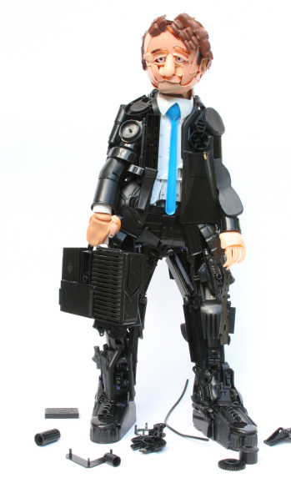 | In analysing the artwork students may draw attention to the following:  - witty use of found objects assembled into a small sculptural human form  - the work uses discarded objects and recycled materials to make comment on human consumption and/or excess  - the sculpture has a technological and sci-fi appearance and could suggest our dependence and use of technologies in contemporary work and society.
Image D  For copyright reasons this image cannot be reproduced in the online version of this document, but can be viewed at http://www.visualarts.net.au/gallery/images/2007/06/jack | In analysing the artwork students may draw attention to the following:  - the central figure is a male dressed in maids clothing in a kitchen  - the male in female clothing may suggest changing roles in society  - the artwork may challenge the viewer’s traditional concept of gender, domesticity and/or traditional family roles  - the work may be interpreted as a humorous comment on the traditional role of men and women  - the use of patchwork, appliqué and stitching is seen as a female domain.
Image E  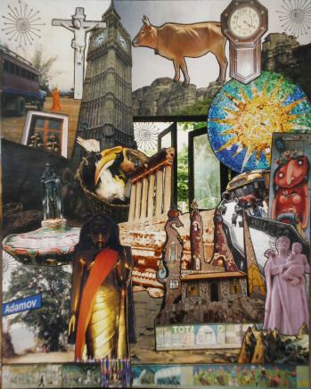 | In analysing the artwork students may draw attention to the following:  - the work is a montage of photographs and images that have been collected and arranged to fill the entire picture space  - the cluttered collection of images show images from different times and places and communicates a religious and spiritual theme  - the door in the centre of the composition leads the viewer’s eye toward greener pastures. This could represent a spiritual journey  - the juxtaposed images may be questioning the role of spirituality and religion in today’s society.
Image F  For copyright reasons this image cannot be reproduced in the online version of this document, but may be viewed at http://www.abcgallery.com/G/grosz/grosz15.html | In analysing the artwork students may draw attention to the following:  - the artwork depicts political figures seated around a table. Some of the figures are headless  - the image is a condemnation of political and business leaders and their role in corruption, political instability and a creating war and harsh economic depression  - the image contains a great deal of symbolism, for example the sun, a symbol of growth, regeneration and life, is eclipsed by a blood stained dollar sign  - Grosz depicts differences between the working classes in society.
Image G  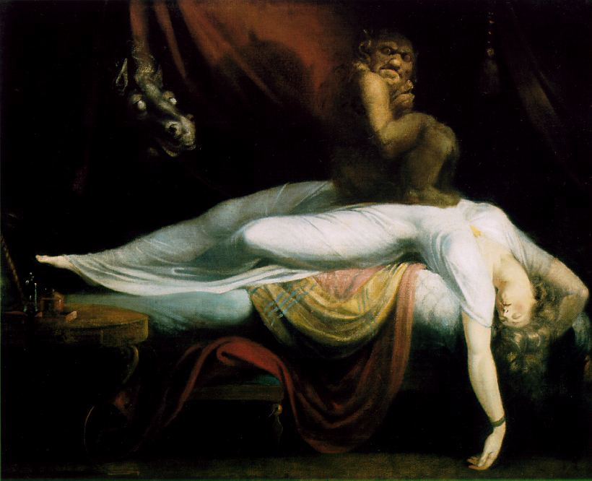 | In analysing the artwork students may draw attention to the following:  - the artwork is painted in the classical tradition and is evident through the realistic depiction and dramatic use of light and shadow.  - a grotesque animal is perched on a dramatically reposed figure.  - the animal in the darkness may be symbolic of our personal or inner demons.  - the figure’s proportion has been exaggerated to emphasise the drama of the nightmare scene.
SECTION THREE
Question 3 (a)

Visual analysis
- Identify and discuss key features of artwork/s
- Recognise how the artwork/s have been constructed
- Discuss materials, techniques and processes used in artwork/s
- Interpret and make judgements about the artwork/s.
10–9 | 8–7 | 6–5 | 4–3 | 2–1
Detailed analysis of artwork/s that explains both the aesthetic qualities and conceptual meanings communicated with selective use of art language. | Objective analysis of artwork/s and identification of key meanings communicated, using appropriate art language. | Basic analysis of artwork/s focused mainly on the formal aspects and/or key features, using a limited range of art language. | Analysis of artwork/s restricted to being largely descriptive and/or emotive with limited use of art language. | Inadequate analysis of artwork/s with minimal use of art language.
Meaning and purpose
- Offer reasons for why the artwork was produced
- Interpret the meanings communicated by the art work/s
- Discuss alternative readings of artwork/s.
10–9 | 8–7 | 6–5 | 4–3 | 2–1
Informed and thorough discussion of concepts, meaning, purpose and value of artwork/s, synthesising varied or conflicting interpretations. | Comprehensive interpretation of meanings communicated in artwork/s. | Straight forward and literal interpretation of artwork and its meaning. | Limited description of artwork/s. | Little or no attempt to discuss the meaning and purpose of artwork/s.  Inadequate response.
Social, cultural and historical contexts
- Discuss the context of artist practice and gives examples of their work
- Discuss social, cultural and historical influences on the work of selected artist/s
- Identify the impact of artist/s on broader context of art practice, production and reading.
10–9 | 8–7 | 6–5 | 4–3 | 2–1
Extensive explanation of the context and critical discourse surrounding artist/s and their work. | Sufficiently detailed explanation of the context surrounding artist/s and their work. | Satisfactory explanation of the context surrounding artist/s and their work. | Limited explanation of the context surrounding artist/s and their work. | Insufficient information about the context surrounding artist/s and their work.

Total marks /30

Question 3 (b)

Personal response
- Express personal opinions about the artwork/s
- Support opinions with evidence from artwork/s.
10–9 | 8–7 | 6–5 | 4–3 | 2–1
Articulates development of own art work and practice in a detailed and interrelated way.  Significant formal and conceptual connections identified between case studies and development of own practice. | Provides reasons for choices made in the development of own art work and practice.  Strong and clear connections made between case studies and development of own practice. | Gives a simple account of their own art practice and development of artwork.  Illustrates some links between case studies and development of own practice. | Provides a brief or limited account of own artwork and practice.  Simple or obvious links made between case studies and development of own practice. | Little or no attempt to describe own artwork and practice.  Little or ineffective links made between case studies and development of own practice.  .

Total marks /10

Stage 2
Mapping questions to content

 | Art Interpretation |  |  |  | Art Making
Question No. | Visual Analysis | Personal Response | Meaning and Purpose | Social, Cultural and Historical Contexts
Section A – Critical Analysis
1 | 2A/2B | 2A/2B | 2A/2B
Section B – Image Analysis
2 | 2A/2B | 2A/2B | 2A/2B
Section C – Case Studies
3 | 2A/2B | 2A/2B | 2A/2B | 2A/2B

Stage 2 Written Examination

Art Interpretation Unit Content Mapping

 | Visual Analysis | Personal Response | Meaning and Purpose
 | Question 1
2A Unit Content | - use critical analysis frameworks including the Frames to analyse artworks from different points of view (subjective, structural, cultural, postmodern)  - use visual arts language and terminology to comment on artworks and discuss their formal organisation. | - provide subjective and objective response to artworks giving reasons for opinions  - support arguments and interpretations when responding to artworks. | - identifying multiple meanings, values and beliefs communicated in artworks  - identify formal, stylistic and technical elements which contribute to the function or messages in artworks.
2B Unit Content | - consolidate the use of critical analysis frameworks including the Frames to analyse artworks from different points of view (subjective, structural, cultural, postmodern)  - respond to unfamiliar works which challenge expectations and preconceived ideas (unseen image analysis) | - support interpretations, opinions and beliefs about artworks and their meanings  - consider alternative viewpoints and opinions when responding to artworks. | - discuss the meaning of artworks from different times and places making links to contextual factors that influence production and reading  - identify formal, stylistic and technical elements which contribute to the function or meanings and messages of an artwork.

 | Visual Analysis | Personal Response | Meaning and Purpose
 | Question 2
2A Unit Content | - use critical analysis frameworks including the Frames to analyse artworks from different points of view (subjective, structural, cultural, postmodern)  - use visual art language and terminology to comment on artworks and discuss their formal organisation. | - provide subjective and objective response to artworks giving reasons for opinions  - support arguments and interpretations when responding to artworks. | - identifying multiple meanings, values and beliefs communicated in artworks  - identify formal, stylistic and technical elements which contribute to the function or messages in artworks.
2B Unit Content | - consolidate the use of critical analysis frameworks including the Frames to analyse artworks from different points of view (subjective, structural, cultural, postmodern)  - respond to unfamiliar works which challenge expectations and preconceived ideas (unseen image analysis | - support interpretations, opinions and beliefs about artworks and their meanings  - consider alternative viewpoints and opinions when responding to artworks. | - discuss the meaning of artworks from different times and places making links to contextual factors that influence production and reading  - identify formal, stylistic and technical elements which contribute to the function or meanings and messages of an artwork.
 | Visual Analysis | Personal Response | Meaning and Purpose | Social, Cultural and Historical Contexts
 | Question 3
2A Unit Content | - use critical analysis frameworks including the Frames to analyse artworks from different points of view (subjective, structural, cultural, postmodern)  - compare and contrast subject matter, meaning and approaches between artworks  - use visual art language and terminology to comment on artworks and discuss their formal organisation. | - provide subjective and objective response to artworks giving reasons for opinions  - support arguments and interpretations when responding to artworks. | - identifying multiple meanings, values and beliefs communicated in artworks  - identify formal, stylistic and technical elements which contribute to the function or messages in artworks. | - identify historical, social, political and religious and other contextual factors that have shaped the development and production of artworks or movements different times and places.
2B Unit Content | - consolidate the use of critical analysis frameworks including the Frames to analyse artworks from different points of view (subjective, structural, cultural, postmodern)  - respond to unfamiliar works which challenge expectations and preconceived ideas (unseen image analysis  - compare artworks using visual art language and terminology discussing formal organisation, meanings and artistic style. | - support interpretations, opinions and beliefs about artworks and their meanings  - consider alternative viewpoints and opinions when responding to artworks. | - discuss the meaning of artworks from different times and places making links to contextual factors that influence production and reading  - identify formal, stylistic and technical elements which contribute to the function or meanings and messages of an artwork. | - examine a range of social, cultural, historical and contextual factors that have influenced or impacted the development and production of artists, groups or movements over time  - examine specific artworks that have been shaped or influenced by specific social, cultural or historical concerns.

